**Lexar® JumpDrive® S80 USB 3.2 Gen 1 Flash Drive**

512GB

256GB

128GB

[Where to buy](https://americas.lexar.com/product/lexar-jumpdrive-s80-usb-3-2-flash-drive/)

**Key Features:**

**Up to 150MB/s read, 60MB/s write speeds**

* USB 3.2 Performance
* 256-bit AES Encryption
* Retractable Connector
* Compatible

**Key Features:**

**Up to 150MB/s read, 60MB/s write speeds**

* USB 3.2 Performance
* 256-bit AES Encryption
* Retractable Connector
* Compatible

**Key Features:**

**Up to 150MB/s read, 60MB/s write speeds**

* USB 3.2 Performance
* 256-bit AES Encryption
* Retractable Connector
* Compatible

**Key Features:**

**Up to 150MB/s read, 60MB/s write speeds**

* USB 3.2 Performance
* 256-bit AES Encryption
* Retractable Connector
* Compatible

**Key Features:**

**Up to 150MB/s read, 60MB/s write speeds**

* USB 3.2 Performance
* 256-bit AES Encryption
* Retractable Connector
* Compatible

[Features](https://americas.lexar.com/product/lexar-jumpdrive-s80-usb-3-2-flash-drive/#feature-section)[Specifications](https://americas.lexar.com/product/lexar-jumpdrive-s80-usb-3-2-flash-drive/#specifications)[Part Numbers](https://americas.lexar.com/product/lexar-jumpdrive-s80-usb-3-2-flash-drive/#product-numbers)[Related products](https://americas.lexar.com/product/lexar-jumpdrive-s80-usb-3-2-flash-drive/#related-products)

**Features**

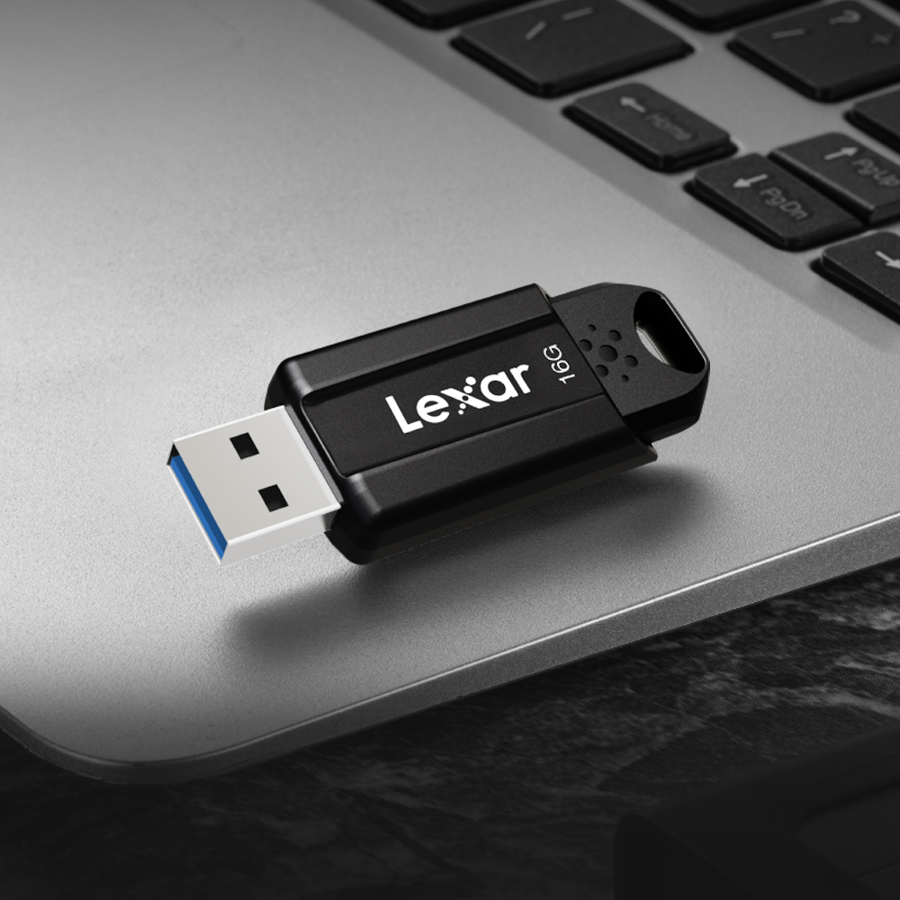

**Faster file transfer with USB 3.2 Gen 1 technology**

Get high-performing read speeds of up to 150MB/s1 to transfer your important files with the Lexar® JumpDrive® S80 USB 3.2 Gen 1 Flash Drive. Quickly transfer a 3GB 4K video in less than 1 minute, compared to the 4 minutes it takes using a standard USB 2.0 drive2. Available in capacities from 16GB to 256GB and includes a three-year limited warranty.

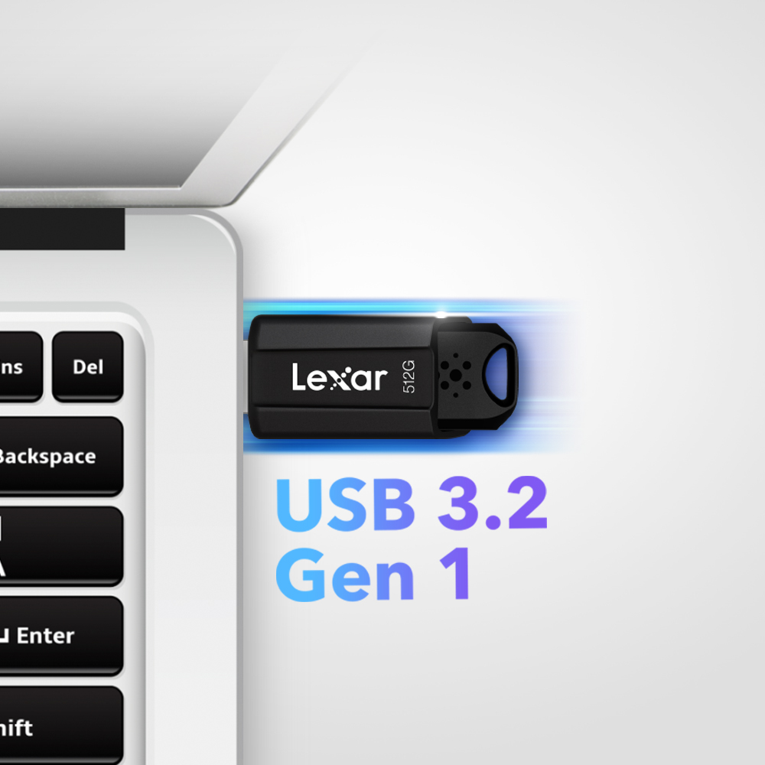

**Store and transfer content faster**

With super-fast speeds up to 150MB/s read and write speeds up to 10x faster than standard USB 2.0 drives3, you can quickly transfer a 3GB 4K movie clip in less than 1 minute, compared to the 4 minutes it takes using a standard USB 2.0 drive2. Backwards compatible with USB 3.0 and 2.0 devices.

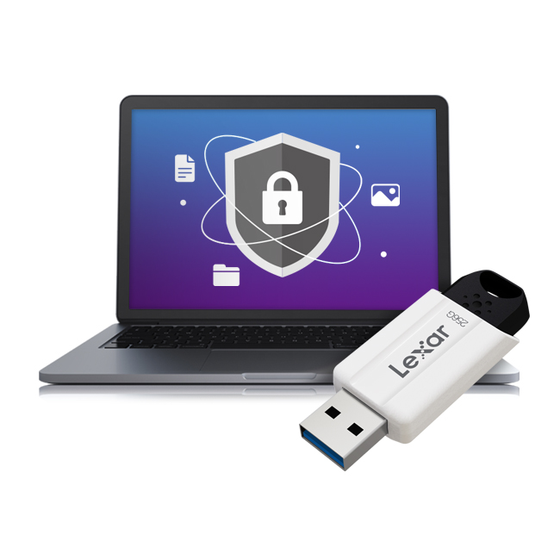

**Securely protect your files**

Looking to protect personal information, financial records, or other sensitive files on the go? JumpDrive S80 includes an advanced security software solution with 256-bit AES encryption to help protect your essential files against corruption, loss, and deletion. Easily create a password-protected safe that automatically encrypts data. And for peace of mind, files that are deleted from the vault are securely erased and can’t be recovered.

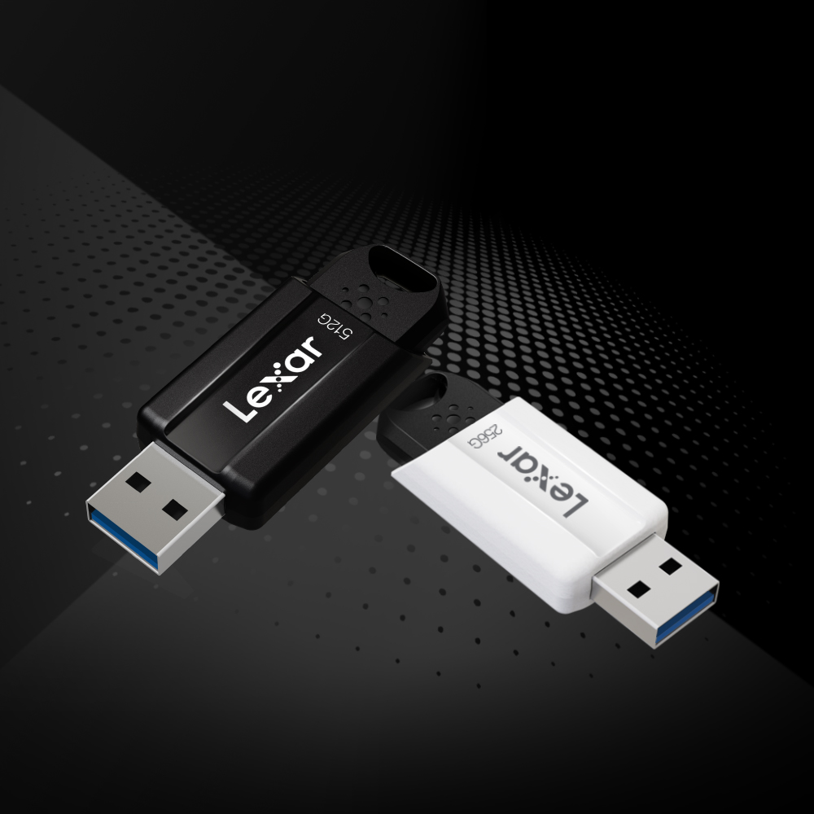

**Store it all with a wide range of capacities**

JumpDrive S80 comes in a wide range of capacities— 512GB, 256GB, 128GB. These options make it easy to find one to suit your needs and store more of your data in one place.



**Rigorously Tested**

All Lexar products undergo extensive testing in the Lexar Quality Labs, facilities with thousands of different cameras and digital devices to ensure performance, quality, compatibility, and reliability.

**Specifications**

* Interface

USB 3.2

* Capacity

512GB | 256GB | 128GB

* Performance

128GB–– up to 150MB/s read, 60MB/s write speeds  
256GB–– up to 150MB/s read, 60MB/s write speeds1

* Operating Temperature

0 °C to 60 °C (32 °F to 140 °F)

* Storage Temperature

-20 °C to 85 °C (-4° F to 185 °F)

* Dimension (L x W x H)

56.5 mm x 20.6 mm x 10.5 mm / 2.22’’ x 0.81’’ x 0.41’’

* Weight

9 g / 0.020 lbs (USB Only)

* Warranty

3 year limited warranty

* Compatibility

PC and Mac® systems

vvv